Time Out for Parents
The Teenage Years
What? A seven-session course for parents of 11-16 year olds
When? Monday evenings: May 13, 20; June 3, 10, 17, 24; July 1
(no session on May 27th – half-term/bank holiday)
Where? HOOK – Life Church Centre, Elms Road, RG27 9DX
Time? 7.30 to 9.30pm – sign in and refreshments from 7.15pm
Course facilitators: Ken & June Shorey and Angie Colebrooke
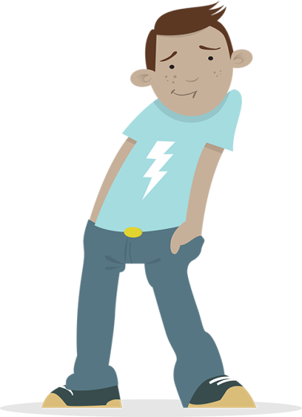 | There is no charge for attending. Participants are invited to make a voluntary contribution to cover the costs and we suggest £25 per parent or £45 for a couple.  This includes a copy of the course handbook (otherwise charged at £7.50).  Tax payers can Gift Aid their contributions. Those who can’t afford it can pay less or come for free without embarrassment.
To book a place (or for further details)  email ken@parenting.org.uk  or telephone 01252 843803 |  | 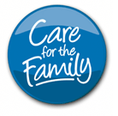
Time Out for Parents
The Teenage Years
A 7-session course for parents of 11-16 year olds
Monday evenings 7.30-9.30pm starting 13th May
in HOOK at the Life Church Centre, Elms Road

- The goal of parenting
- Temperament and emotional needs
- Love languages
- Why it’s tough being a teenager
- Identity and independence
- Staying connected
- Peer pressure and self-esteem
- Parenting styles – assertive parenting
- Consistency
- House rules and family meetings
- Communication
- Body language, listening, empathy
- Conflict and negotiation
- Choosing your battles
- Consequences and sanctions
- The big issues – sex, drugs and money
- Online safety and pornography
- Building strong families
- Hidden goals behind behaviour
- Values and traditions
Book by email to ken@parenting.org.uk giving a contact phone number
Positive Parenting is part of Care for the Family, a registered charity (number 1066905)
Positive Parenting courses are for parents of all faiths and none.
To book a place, ring 01252 843803 or email ken.shorey@cff.org.uk
Positive Parenting is part of Care for the Family, a registered charity (number 1066905)
Telephone: 0845 643 1939 Web: www.parenting.org.uk
Registered Office: Garth House, Leon Avenue, Cardiff, CF15 7RG

